


CC4057/58NI Introduction to Information System
60% Group Coursework
Submission: Milestone 1
Academic Semester: Autumn Semester 2025
Credit: 15 Credit Semester Long Module

Group Name:
SN | Student Name | College ID | University ID
1 | Prince Maharjan(Section) | College Id | University Id
2 | Karan Khatiwada  (Section) | College Id | University Id
3 | Norgay lama  (Section) | College Id | University Id
4 | Sanjeewani Shrestha (Section) | NP01CP4A250061 | University Id

One Drive Link:
Assignment Due Date:
Assignment Submission Date: 16th January, 2025

I confirm that I understand my coursework needs to be submitted online via MST Classroom under the relevant module page before the deadline for my assignment to be accepted and marked. I am fully aware that late submissions will be treated as non-submission and a mark of zero will be awarded.
Table of contents
1. Introduction 5
1.1 Introduction to the Project 5
1.2 Goals and Objectives 6
1.3 Technologies Used (HTML, CSS, JavaScript) 7
1.4 Verdict 8
2. Documentation: Discussion & Analysis 9
2.1 Selected Text Editor 9
2.2 Wire Frame Development Tool 9
2.3 Individual Page Documentation 10

Table of figures

Table of tables

- Introduction
- Introduction to the Project

Eco Mart is an eco friendly website which is designed to help and make our environment cleaner and waste-free by helping the users to buy and sell different products which are eco friendly and helps to reduce the environmental waste in our society as well as our surroundings. Our website is designed in such a way that It includes lightweight designs so that the users without any prior knowledge about any modern technology to efficiently buy or sell the goods or Products while also reducing data transfer and energy use. Our website is developed by a group of four people who aims to reduce global waste.

The main purpose of our website eco mart is to provide consumers with environment friendly and sustainable products and to promote green sustainable and waste-free environment that reduces environmental impacts by using recycled or energy efficient items and raise awareness about sustainable practices. Ultimately, Our main purpose is to create a healthier and more environment friendly and energy efficient planet.

- Goals and Objectives
Goals
- Make our Earth healthier.
- Make the majority of people use environment friendly tools and products.
- Save the planet from harmful chemicals and waste products.
- To help the customers without any prior knowledge by making it easily accessible and understandable while using our website.
- To make the eco friendly products easier to access and available to anyone and everyone.
Objectives
- Promote the use of eco friendly tools.
- To minimize data uses through optimized design and performance.
- To promote Reduce Reuse and Recycle.
- To make the people understand about the harmful impacts of using chemicals and other harmful wastes.
- Spreading awareness about the benefits of using sustainable and eco friendly tools and products

- Technologies Used (HTML, CSS, JavaScript)
- HTML
- Hypertext markup language HTML ease and markup language which is used to create the structure of the websites it is also known as the skeletal system(backbone) of the website as it creates the structure for the website just as how an human body is structured by the skeletal system. Here we use the HTML or HTML to create web pages just like our products, home page and all the other pages. HTML helps us to create different hyperlinks as well as to connect to CSS and JavaScript.

- “HTML (HyperText Markup Language) is the most basic building block of the Web. It defines the meaning and structure of web content. Other technologies besides HTML are generally used to describe a web page's appearance/presentation (CSS) or functionality/behavior (JavaScript)."Hypertext" refers to links that connect web pages to one another, either within a single website or between websites. Links are a fundamental aspect of the Web. By uploading content to the Internet and linking it to pages created by other people, you become an active participant in the World Wide Web.An HTML element is set off from other text in a document by "tags", which consist of the element name surrounded by < and >. The name of an element inside a tag is case-insensitive. That is, it can be written in uppercase, lowercase, or a mixture. For example, the <title> tag can be written as <Title>, <TITLE>, or in any other way. However, the convention and recommended practice is to write tags in lowercase”(MDN Web Docs, 2025).

- CSS
- CSS or Cascading Style Sheets is like the skin of the websites because the main purpose of CSS is to help decorate the webpages just like how the skin of our human body decorates our body. its main purpose is to decorate the web pages to make it more presentable ,attractive and unique.

- There are three types of CSS or cascading style sheets they are as follows :-
- External CSS : it creates a separate file which contains the (.CSS) extension that contains the styles or rules for one or more HTML document. This file is then linked to HTML pages using the link element within the <head> of the HTML document or by using the rel attribute which is set to style sheet.
Eg : (mart1.css).
- Internal CSS: internal CSS is also known as embedded CSS it is a method of defining CSS styles directly within the HTML file by using the “style” attribute within the “head” tag of the HTML document or file. It overwrites the External CSS.
- Inline CSS : It refers to the method of applying CSS styles directly within a HTML element it is used by using the style attribute which allows us to use all the CSS codes in a single line it overwrites the internal CSS and external CSS.

- Verdict
- According to my team we have came to a single verdict which is that we must first complete each and every objective and our goals and then we must promote user friendly interface to make it clean and simple. We also understood that using HTML, CSS and JavaScript can help us a lot during our project creation while it lacks interactivity at this stage due to the absence of JavaScript it is a well structured website with a lot of dedication by my teammates and me. We have came to the single conclusion that this website potentially may help in the future to I believe selling various eco friendly products and reducing the harmful risks created by the use of unsustainable practices in our society.

- Documentation: Discussion & Analysis
  - Selected Text Editor
- Here we used VS Code (Visual Studio Code) because : -

- It provides different Extensions for us to use which makes it easier to use.
- It provides us with a live server i.e. we can use the website and see edits without refreshing our pages.
- It is more convenient as we can share our projects and its code directly and work on it as a project.

- It has helped us a lot in development as because of the live server extension we can see the edits happening live so we know where our errors lie in, we could also help each other out by working in the same project at the same time because of which we could help each other out when facing any difficulty and importantly it help us to organize our codes to a more cleaner and attractive layout.

  - Wire Frame Development Tool
- We use “Balsamiq” as an Wire Frame development tool
- We simply created out wire frame by taking out references from various websites such as Daraz (2026) Amazon (2026) .According to these websites we built an wire frame by using the tools available in the balsamiq website.

  - Individual Page Documentation
- Home Page
- The home page is the main entry point of the website everybody looks at the website and starts at the home page of the website this is designed to give users a clear overview of the platform it includes the navigation bar so that it helps the users to navigate to different sections such as home, about us, blog, products and many other pages the main feature of the homepage is that it uses a parallax banner section that officially operates as a brand and has the logo eco Mart .Our main viewpoint is that we have a see more button which is included to guide users to the product page and give us an over view of the products. Below the prod (Docs, n.d.) (Docs, n.d.)ucts as you can see the arrow key which leads to the product page .home page also contains Blog / Latest Insights section where there are many recent articles and latest updates are displayed by using the “See more” button you can use it or click it simply to access to the blog page.

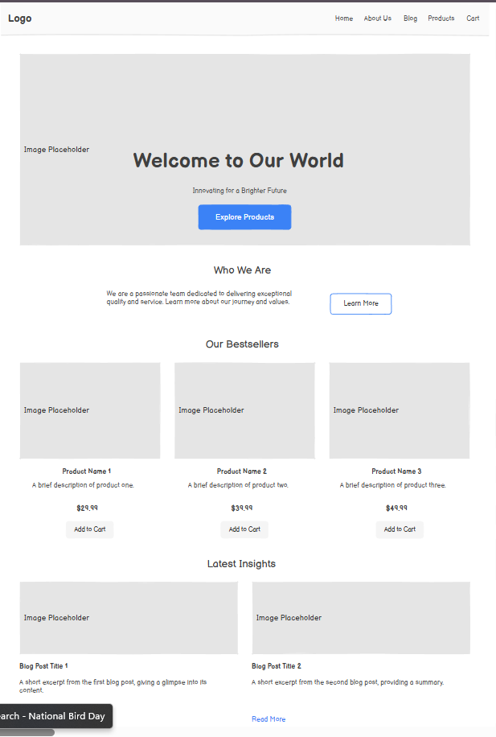
- Products

- Research

- About Us

Karan
1. Font Awesome Icons
We get icons from: https://fontawesome.com/

This line in HTML gets the icons:
<link rel="stylesheet" href="https://cdnjs.cloudflare.com/ajax/libs/font-awesome/6.4.0/css/all.min.css">

2. HTML Stuff We Used
HTML5 (the latest HTML)
<header>, <nav>, <main>, <footer> - Page structure
<input> - Search bar and filters
<button> - Clickable buttons
<div> and <span> - Containers and text

3. CSS Stuff We Used
CSS Grid - Product layout
CSS Flexbox - Navigation alignment
CSS Variables - Colors
Media Queries - Responsive design
Hover Effects - Mouse interactions

4. Colors We Used
Dark background: #121212
Card background: #1E1E1E
Green: #4CAF50
Light Green: #81C784
White text: #E0E0E0
Gray text: #9E9E9E
Border: #2C2C2C
Button Hover: #388E3C

5. Mobile Responsiveness
@media (max-width: 768px) - Tablet view
@media (max-width: 576px) - Mobile view
flex-direction: column
grid-template-columns: 1fr

6. Simple Animation
transition: all 0.3s
transform: translateY(-5px)
@keyframes fadeIn

7. Learning Resources
w3schools.com
MDN Web Docs
freeCodeCamp.org
CSS-Tricks.com

References
Docs, M. W., n.d. HTML. [Online]
Available at: https://developer.mozilla.org/en-US/docs/Web/HTML

Daraz (2026) available at https://www.daraz.com.np/ [accessed 7 th january 2026],
Amazon (2026) available at https://www.amazon.com/[accessed 7 th january 2026].
MDN Web Docs (2025) HTML: HyperText Markup Language. Available at: https://developer.mozilla.org/en-US/docs/Web/HTML (Accessed: 11 January 2026).

